Array.h

#ifndef ARRAY_H

#define ARRAY_H

#include <iostream>

using namespace std;

// Class definition

class Array

{

private:

int* arr;

int capacity;

int size;

void moveTowardFront(int index);

void moveTowardEnd(int index);

public:

Array(int capacity);

~Array();

void insert(int value);

void remove(int value);

void print() const;

};

#endif

Array.cpp

#include "Array.h"

Array::Array(int cap)

{

capacity = cap;

size = 0;

arr = new int[capacity];

}

Array::~Array() {}

void Array::moveTowardFront(int index) //when delete

{

for (int i = index; i < size-1; i++) {

*(arr + i) = *(arr + i + 1);

}

}

void Array::moveTowardEnd(int index) //when insert

{

for (int i = size; i >= index; i--) {

*(arr + i + 1) = *(arr + i);

}

}

void Array::insert(int value)

{

int index = 0;

for (int i = 0; i < size; i++) {

if (*(arr + i) < value) {

index = i;

break;

}

else {

index = size;

}

}

moveTowardEnd(index);

*(arr + index) = value;

size++;

}

void Array::remove(int value)

{

int index = 0;

bool found = false;

for (int i = 0; i < size; i++) {

if (*(arr + i) == value) {

index = i;

found = true;

moveTowardFront(index);

size--;

}

}

if (found == false) {

cout << "Cannot delete " << value << " because it is not in the array" << endl;

}

}

void Array::print() const

{

for (int i = 0; i < size; i++) {

cout << *(arr + i) << " ";

}

cout << endl;

}

Main.cpp

/******************************************************

* The application file to test the sorted array class *

******************************************************/

#include "Array.h"

int main()

{

// Declaration of any array of capacity 20

Array array(20);

// Inserting some elements and printing array

array.insert(15);

array.insert(13);

array.insert(10);

array.insert(14);

array.insert(11);

array.insert(17);

array.insert(14);

cout << "Printing array after insertions: " << endl;

array.print();

cout << endl;

// Removing two elements and printing array

array.remove(13);

array.remove(11);

cout << "Printing array after removals: " << endl;

array.print();

cout << endl;

// Inserting two more elements and printing array

array.insert(8);

array.insert(22);

cout << "Printing array after more insertion" << endl;

array.print();

cout << endl;

// Try to remove an element, which is not in the array

array.remove(31);

return 0;

}

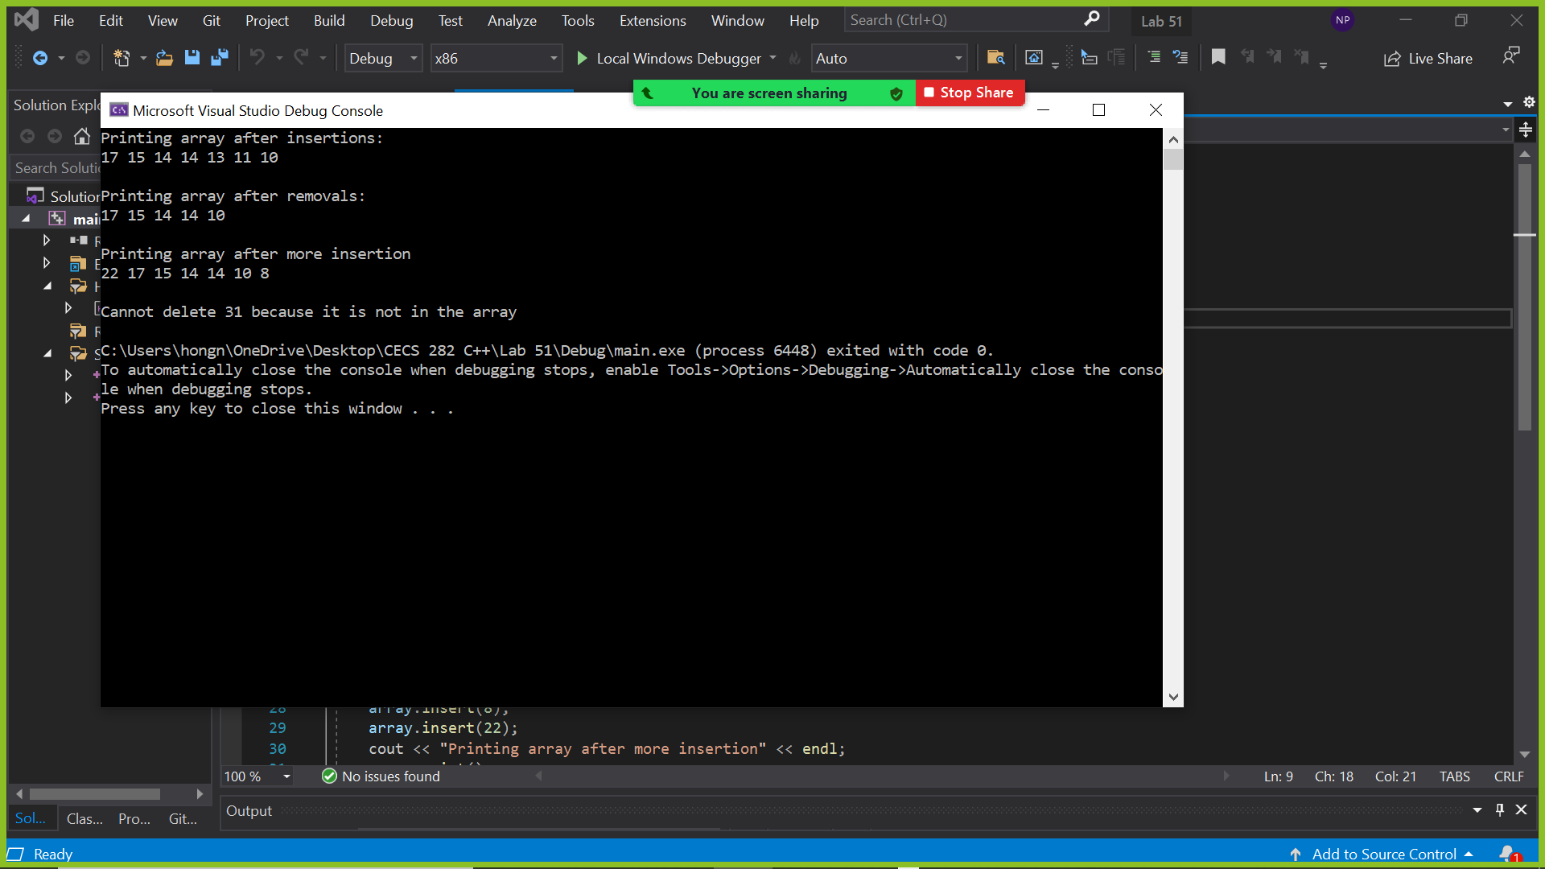

Demonstrated at 11:04am on September 16, 2021